Notes from CompTIA CySA+ Cybersecurity Analyst Certification All-In-One Exam Guide

**Detailed exam objectives:**

[**https://www.comptia.jp/pdf/comptia-cybersecurity-analyst-(cs0-001).pdf**](https://www.comptia.jp/pdf/comptia-cybersecurity-analyst-(cs0-001).pdf)

**Exam category emphasis**

**Threat management (27%)**

* **Vulnerability management (26%)**
* **Cyber incident response (23%)**
* **Security architecture and tool sets (24%)**

**Lots of specific info on the exam itself:**

[**https://resources.infosecinstitute.com/category/certifications-training/cysa-plus/cysa-plus-exam-information/**](https://resources.infosecinstitute.com/category/certifications-training/cysa-plus/cysa-plus-exam-information/)

**The study guide I found on Reddit and saved to my drive:**

[**https://www.reddit.com/r/CompTIA/comments/bc79qi/free_cysa_csa_study_guide_for_you_all/**](https://www.reddit.com/r/CompTIA/comments/bc79qi/free_cysa_csa_study_guide_for_you_all/)

**!!!Practice test with performance based questions comes with the book as free download. Has to install so put on personal computer!!!**

[**http://www.totalsem.com/1260011801d**](http://www.totalsem.com/1260011801d)

**Cybrary Exams**

**Skillport TestPrep CS0-001 CompTIA Cybersecurity Analyst (CySA+)**

**Is a practice test. (may be the same as the one included with this book?)**

**Official CompTIA Labs for $70 might be worth it for hands on questions and familiarity with logs and firewall rules, etc.**

[**https://academic-store.comptia.org/p/VLABCYSA**](https://academic-store.comptia.org/p/VLABCYSA)

**Exam voucher for $226** [**https://academic-store.comptia.org/p/ACADCompTIACSA**](https://academic-store.comptia.org/p/ACADCompTIACSA)

**Chapter 1**

1. Difference between NFV (Network functions virtualization) and SDN (Software Defined Network)
   1. Not clear what the difference is still after some research
   2. Neither is specifically on the objectives or in other study resources
   3. SDN executes on an NFV infrastructure, SDN forwards data packets from one network device to another
   4. NFV aims to virtualize all physical network resources beneath a hypervisor, which allows the network to grow without the addition of more devices.
   5. Thus, NFV provides basic networking functions, while SDN controls and orchestrates them for specific uses.
      1. **Don’t worry about it**
         1. **Cool cool cool**
            1. **That’s enough Peralta!**
2. Container
   1. Like a Hypervisor, but shares kernels with regular system OS to use less space and be more efficient
      1. Therefore you can’t have Linux container on Windows without some fanciness

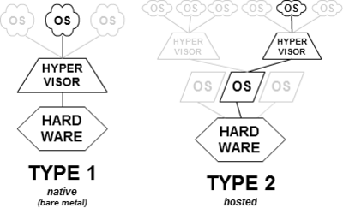

1. Reconnaissance tools (more listed in book. Take some time looking at results from each one)
   1. Nitko
      1. Web server vulnerability scanning tool
   2. OWASP Zed Attack Proxy
      1. Like Nitko but can serve as a web proxy
   3. WHOIS
      1. Uses ARIN queries to check ownership info for a domain
   4. NMAP
      1. Know the default packets sent in a scan
         1. Ex) TCP ACK to Port 80
         2. Options for scans
            1. <https://nmap.org/book/man-port-scanning-techniques.html>
2. Social engineering terms from ch1 question 12
   1. Pretexting
      1. Fabricating a scenario where they need info
   2. Tailgating
      1. I guess it’s social engineering if you pretend you’re carrying something
   3. Footprinting
      1. This one is reconnaissance not social engineering
      2. Gathering info about the network setup of the target

**Chapter 2**

1. SNORT
   1. Open source Network based Intrusion Detection system
   2. Can also be packet analyser or IPS
   3. See how rules are set up on last page of ch2
2. NGF
   1. Next-Generation Firewall (NGF) incorporates functionality from both traditional firewalls and IPSs.
   2. Can usually detect malware using heuristics based on it’s behavior in a VM
3. Packet Header contents
   1. Need to look at what each thing is (Internet Engineering Task Force's RFC 791 for version 4 and RFC 5871)
   2. 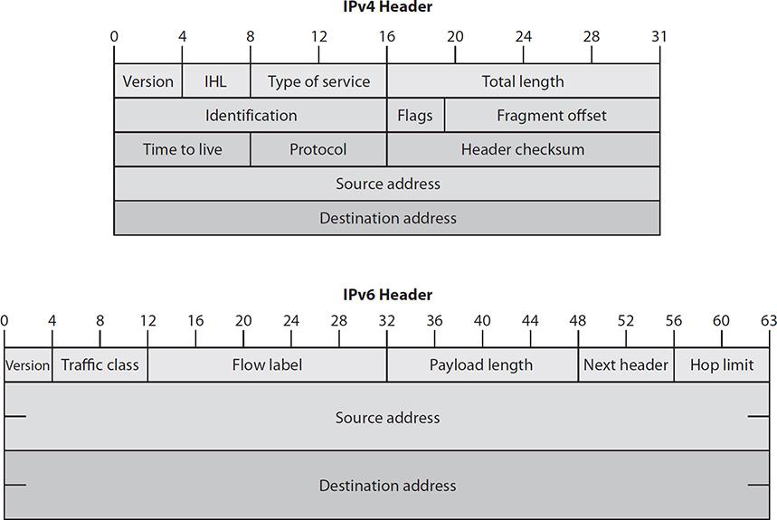
   3. “The exam will focus on IPv4”
      1. The header length is in bits 4 through 7 (labeled IHL (IP Header Length))
4. Logs to know
   1. Firewall logs
   2. Windows event logs and syslog
5. MTU = Maximum Transmission unit
   1. Largest packet size allowed
6. Two types of analysis
   1. Point in time = Time frame
   2. Correlation = Comparisons
7. Need to know protocol analysis = Look at how well packets conform to established protocols
8. Etherape is for analysing how much traffic is going to end-points
   1. 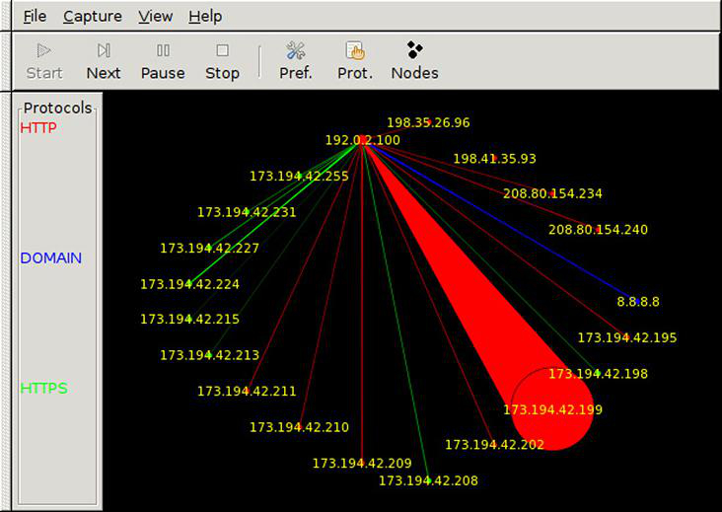
9. Netflow
   1. Groups packets into “flows” based on destination, source, protocol, and IP service type
   2. Captures aggregated statistics on flows not full packets
10. WLAN analysis
    1. Kismet tool
       1. Puts your network card into monitor mode. Detects all wireless traffic without connecting
11. Lloyd = needs more explanation on wireless analysis WLAN audit
12. Anomaly and Behavioral analysis
    1. Leverage baselines
    2. Data correlation and analysis types
13. Trend analysis
    1. Over long time to determine the most common attack types etc
       1. Internal Trend = Making policy change for moving data to a Dropbox
       2. Temporal Trend = Popular times for breaches
       3. Spatial Trend = Has to do with being in different regions
14. SIEMS
    1. Splunk
    2. ELK (Elasticsearch, Logstash, and Kibana) (Open Source)
       1. Three open source tools combined to make a SIEM
          1. Elasticsearch (search engine) indexes data
          2. Logstash ingests data and removes PII then forwards to data store
          3. visualization plug-in for Elasticsearch to view/present data
15. IDS
    1. Host based or Network based
    2. Signature or anomaly based
    3. Standalone or part of another platform like NGF
16. Bro
    1. Signature and Anomaly based
    2. Features explained well at end of Ch2
17. Suricata
    1. Like snort but multithreaded (whatever that means)
    2. Can do hardware acceleration (use graphics card to help process)
    3. Can be IPS like BRO and Snort
18. Resource monitoring
    1. Nagios uses plugins to monitor switches, routers, hard drive utilization etc
    2. Notifies when conditions are met
19. Netflow analyzer
    1. Ntopng
       1. Can receive netflows from multiple sources and has analysis console

**Chapter 3**

1. Jump Box (AKA Jump server)
   1. Segments the network by requiring access to go through this hardened box with special credentials for access to sensitive parts of network
   2. Behind a firewall

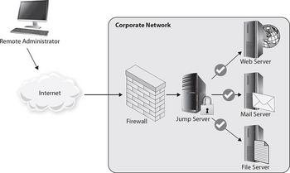

1. Black hole
   1. Receives all traffic with certain source/destination and provides no response at all
2. DNS Sinkhole
   1. DNS requests for known malicious sites resolve to spoofed IP so it won’t connect
   2. SINKHOLES PREVENT CONNECTION
3. Access Control types *The order of the rules is important
   1. DAC (Discretionary Access Control)
      1. Access is at the discretion of the file/resource owner
      2. Need permission whereas MAC is permission unless…
   2. MAC (Mandatory Access Control)
      1. Matches resource classification levels with user clearance levels
      2. Better than DAC
   3. RBAC (Role-Based Access Control)
      1. Access restricted to certain groups based on roles
         1. Unlike DAC, no individual user access granted
   4. Compensating controls
      1. When you can’t meet the original security goals, but find a way to make it work through some form of access control, network architecture, etc.
4. Ports
   1. Need to find out if I really need to memorize these at all
5. Micro-segmentation
6. Honeypots should be as far from production servers as possible
   1. Used to gain insight on how the adversary attacks
   2. Honeynet is a whole network designed to be attacked
   3. See Ch3 question 7
   4. TRY A VIDEO FOR PLACEMENT STUFF ON NETWORKS
      1. Skillport or Udemy
7. Sandbox locations
   1. See Ch3 Q 8 Answer
      1. How does this diagram tie circle 4 to circle 5?
   2. Goes on endpoint devices usually
8. Blocking unUsed ports/services is an example of system hardening
9. Ch3 Q 10 is tricky but shows what to pay attention to

**Chapter 4**

1. Pen testing
   1. Recon
   2. Exploit
   3. Lateral move
   4. Report to management
   5. Types
      1. 0 knowledge
      2. Partial knowledge
      3. Full knowledge
   6. Gotta get an authorized letter saying that you can test “Get Out of Jail Free Card”
2. Assembly code
   1. Between source code and machine language
   2. Specific to processors and hardware it’s running on
   3. Binary can be reassembled into assembly code, but assembly code often can’t be turned into source code since many different programming languages utilize the same assembly codes
3. Cuckoo Sandbox
   1. Isolation sandbox with tools to determine what malware is doing
   2. Runs on windows, linux, MAC, and Android
4. Trusted Foundry
   1. Established by DoD to certify that hardware is being developed in a manner that can be trusted and free of foreign threat actors
5. Executable formats
   1. Windows
      1. Begins with “Magic Numbers” **5A 4D or 4D 5A**, depending on which operating system you are using to inspect the file
      2. Also usually says “This program cannot be run in DOS mode”
   2. Linux
      1. Begins with “Magic Numbers” 7F 45 4C 46
6. Excercises
   1. Tabletop
      1. Technical control infrastructure
   2. Live-Fire
      1. Blue team exercise

**Chapter 5**

1. Regulatory environments with vulnerability scan requirements

##### Things like ISO, Payment Card Industry Data Security Standard (PCI DSS), and HIPAA

##### **You do not have to memorize these**, but you need to know there are regulatory environments that require vulnerability management.

1. Classification levels of data are based on
   1. sensitivity of data include the level of damage that could be caused if the data were disclosed
   2. legal, regulatory, or contractual responsibility to protect the data
   3. **age of data**
      1. Remember age apparently matters
2. functional policy
   1. For specific issues within a corporate security policy
3. Industrial Control Systems (ICS)
   1. Frequently connected to regular IT infrastructure with internet access nowadays
   2. 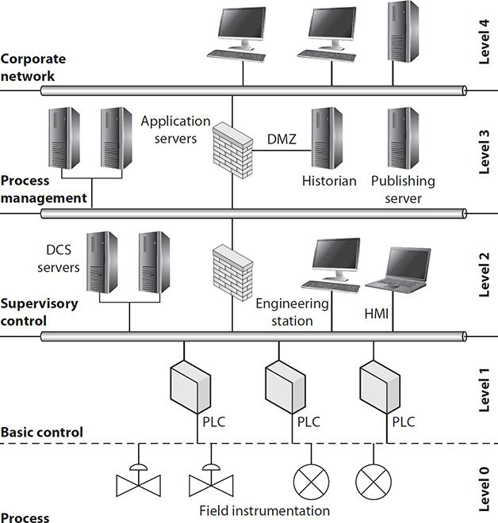
      1. Layers 0-2 are the Operational Technology (OT) network
         1. 0 is physical equipment
         2. 1 is remote terminal units (RTUs) or programmable logic controllers (PLCs)
            1. Translate between physical effects to binary data
      2. Level 2 HMI Human Machine Interaction
      3. Layers 3 & 4 are the IT network
   3. PLCs are on firmware and cannot be updated while working
      1. Frequently not patched and often patches not even available
      2. Passwords often documented for anyone and very difficult to change + done in plaintext and very simple
   4. Supervisory Control and Data Acquisition (SCADA) devices
      1. Large ICS used for pipelines, power grids, utilities etc.
      2. 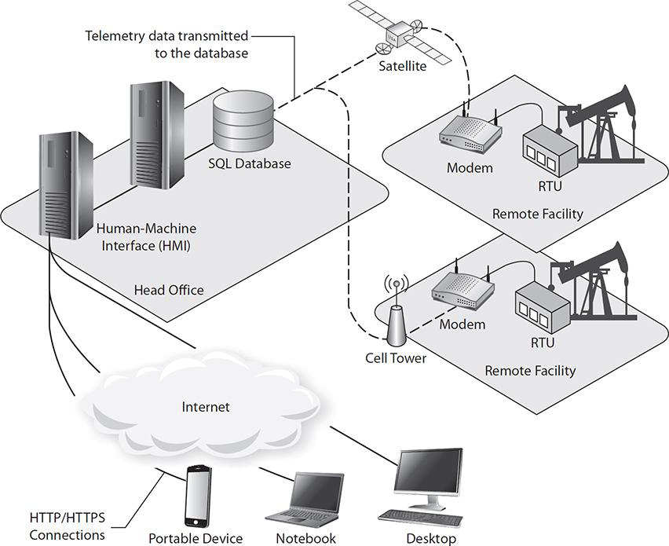
      3. Two additional vulnerabilities
         1. Long distance communication links
         2. Remote unattended facilities for physical access by attackers
4. Vulnerability Feed
   1. Databases available to organizations/publicly with vulnerability lists that are updated
   2. Choose one that updates about as often as your vulnerability scanning schedule
5. Server-based vulnerability scanners
   1. One server sends out a bunch of network traffic to many hosts
6. Credentialed vs. Non Credentialed scan
   1. Credentialed = More through scan (inside and outside network scan)
   2. Non Credentialed = evaluated the system from an outsider perspective
7. Agent-Based scanning
   1. Each computer has its own scanning program or “agent” that reports to central scanner
   2. Less network traffic and **better for mobile devices**
8. Vulnerability Scanner plugins
   1. Looks for a specific flaw
   2. On Nessus written in Nessus Attack Scripting Language (NASL)
      1. 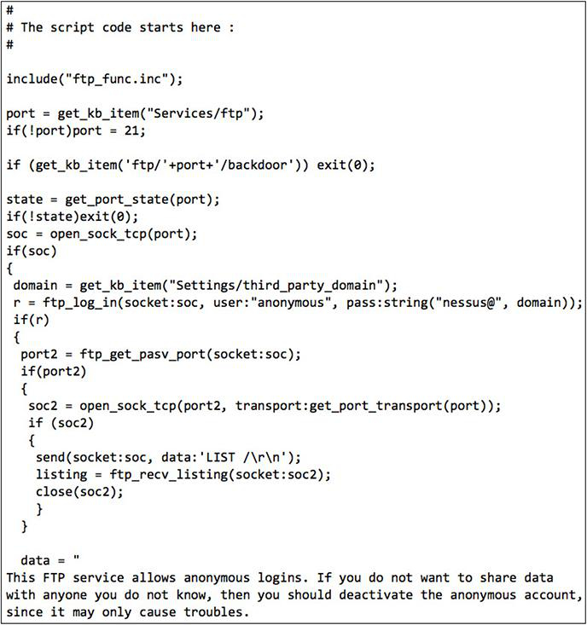
         1. This NASL script shows a portion of a NASL plug-in that tests for FTP servers that allow anonymous connections
9. SCAP (Security Content Automation Protocol)
   1. NIST standard for reporting vulnerabilities across different scanning tools
   2. Formats used (Probably don’t need to know these. Try the official study guide to see):
      1. asset reporting format (ARF)
      2. Common Vulnerabilities and Exposures (CVE)
      3. Common Vulnerability Scoring System (CVSS)
   3. Has modules for different standards that you put into any SCAP certified scanner
      1. This automates the whole vulnerability management process!
10. Good practice to make an account specifically for the scanner to run under
    1. Or run under non-admin account of person in charge of scanning
    2. Have to allow it in ACLs and watch for triggering IDSs, host-based security systems (HBSSs), etc.
    3. Definitely secure the results of scans securely too!
11. Best practices dictate that VPN client software be installed only on organizationally owned and managed devices
    1. Maybe re-read a bit of the VPN Section

**Chapter 6**

1. I should probably just practice a bit with nessus on my home network and lookup and interpret output and screens from OpenVAS and Nikto
   1. There are screenshots throughout the Chapter though
   2. Probably wanna buy the CompTIA labs since this may include questions on what the best steps to remediate are which could get pretty technical in terms of protocol implementation etc.
2. NVT = Network Vulnerability Test
3. Nessus
   1. Requires a server which does the scan, and a webclient for managing it
      1. Can be on the same device
   2. Safe Check option tells you which tools might cause damage
   3. Compliance checking
      1. 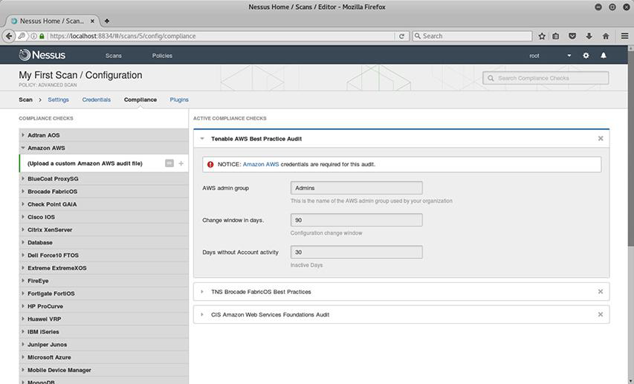
      2. Checks the configurations of machines against pre-developed or custom Audit Files
      3. More resource intensive for targets of scan
         1. More likely to trigger alerts on endpoints/security devices
4. OpenVAS
   1. What the original open source Nessus became
      1. Uses server and webclient too
      2. Same as Nessus as far as this part of the book is concerned
      3. 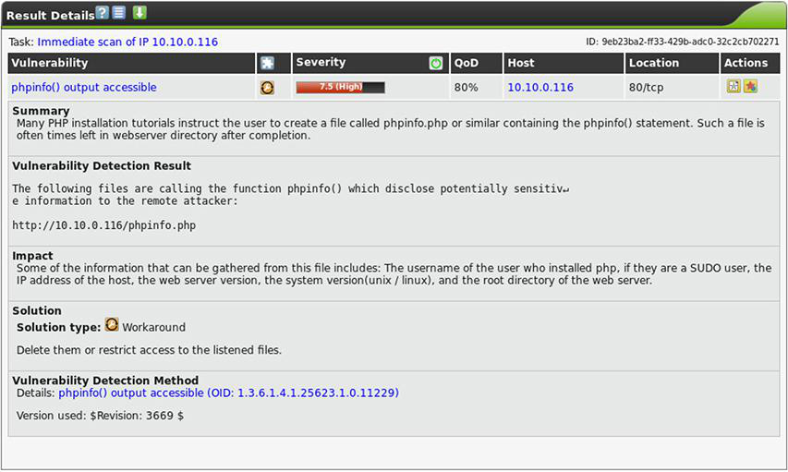
         1. Vulnerability output
5. Nikto
   1. Scans web servers
      1. Included on Kali Linux
      2. Command line utility only
   2. “-host” parameter followed by IP address to scan
      1. 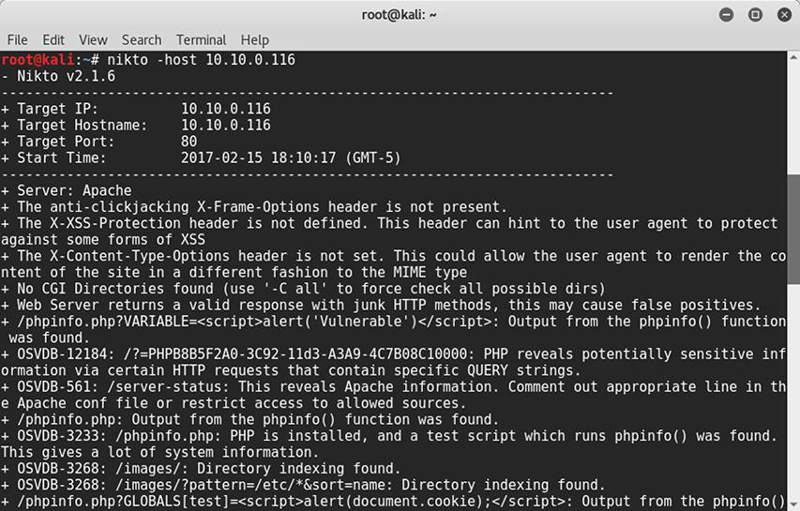
         1. XSS = Cross site scripting
6. Remediation
   1. If using compensating control rather than patch:
      1. Add a note to the report
      2. Or override the alert
   2. The Common Vulnerability Scoring System (CVSS) is the standard for assessing the severity of vulnerabilities.
      1. Therefore, you should be familiar with CVSS and its metric groups: base, temporal, and environmental.
   3. Involve non-technical personnel for compensating control if you can’t remediate quickly
7. Change Advisory Board (CAB)
   1. Used by organizations to ensure changes like patches don’t just make things worse and are documented and approved
8. Good practice to sandbox a patch first to ensure it’s not opening some new vulnerability
9. Memorandum of Understanding (MOU)
   1. Between orgs with interdependent systems helps determine how to proceed when vulnerabilities are found
   2. Has formal Rules of Engagement (ROE)
      1. State what can be done during the scan and in the event of issues
10. Service Level Agreement (SLA)
    1. Contract within or between companies defining limit of services to be performed
11. Scans depend on identifying the OS which is not always perfect
    1. Custom OS’s like lightweight linux/apache servers tend to give false positives
12. Defense Information Systems Agency
    1. DoD resource for secure configuration
    2. Has STIGs (Security Technical Implementation Guides) with steps to implement
    3. Use alongside NSA guides
13. Tracking remediation
    1. Nessus and OpenVAS let you track corrective actions
    2. Can use external ticketing systems to track corrective actions as well
14. Check system logs and network data alongside scan results
    1. Lets you ensure logs are being generated on the hosts based on the actions of scanning
    2. You can see network changes (to protocols being used etc.) due to patches and implemented controls
    3. Can ensure vulnerabilities discovered haven’t already been exploited
    4. SIEMs are very useful for this
15. Ch6 Q 2
    1. Difficulty of implementation is a consideration in prioritizing remediation
    2. A SCAP score apparently isn’t so I guess it is not the same as a CVSS??

**Chapter 7 Incident response process**

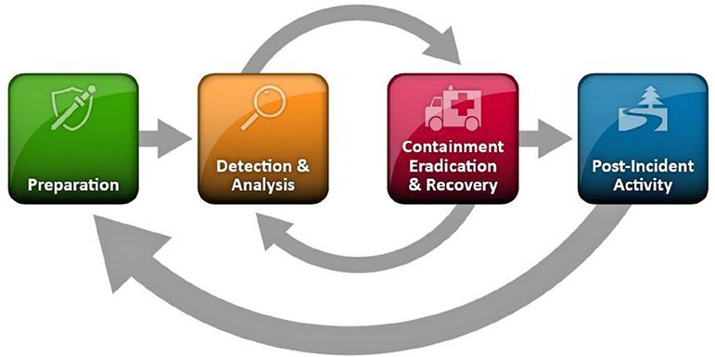

1. Typical Escalation
   1. 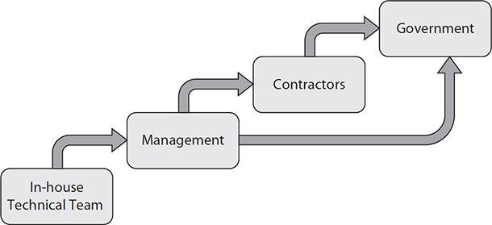
2. Technical incident responders plan
   1. Use risk management plan to determine likely incidents then figure out who should make decisions in that scenario
      1. Determine if that person has the right authority and either get them the authority or change people
3. Contractors
   1. Don’t outsource all IR
      1. Need a person who knows the business side and roles of individuals
4. LEA = Law Enforcement Agency
5. HR
   1. Involved when it is insider threat (malicious or accidental)
   2. Involved when response requires overtime/loss of vacation
6. Legal team
   1. Supports reporting requirements and governance such as HIPAA
7. Marketing
   1. Need to be involved in planning so they know what is going on so they don’t lose public trust
      1. Need the technicians to explain things in plain language
8. Event and incident may be tested as different terms in some way meant to throw you off
   1. Event: any occurrence that can be observed, verified, and documented
   2. Incident: one or more related events that compromise the organization's security
9. RE = Reverse Engineering
   1. Dynamic Analysis
      1. Sandbox malware and see what it does
      2. Easier, but may not reveal everything the malware does
   2. Static analysis
      1. Looking at the code
      2. Assembly language is the one between machine language and source code
      3. Compiling is changing to assembly language; assembling is changing assembly into machine
10. Sanitization
    1. In order of effectiveness below
       1. Cursory Sanitization
          1. Something easy like reformatting hard drive
       2. Overwriting
          1. May have to be done more than once
             1. Why?
          2. Only for hard drives and some SSDs
       3. Encryption (and throw away the key)
          1. Securely deleting the key is faster than deleting encrypted data once you’ve already encrypted it
          2. Usually an option on workstation. Server, or mobile OS
       4. Degaussing
          1. Wiping with a powerful magnet
          2. Often makes a drive unusable since it can break the motors and writing mechanism
          3. Only for magnetic media
             1. Newer media might have stronger fields so older degaussers won’t work
       5. Physical Destruction
          1. Shred, caustic chemicals, incinerate
          2. Usually the only option for a compromised router or switch
11. Gold Masters
    1. Known-good, configured image for reconstructing a computer
12. IOCs = Indicators of compromise
13. TTP = Tactics, Techniques, and procedures
14. Validation
    1. Ensuring attack vectors have been found and proper countermeasures have been established
    2. Steps can include
       1. patching
       2. Permissions
          1. Delete compromised account and determine whether accounts running unnecessary permissions
       3. Scanning
          1. Ensure no more instances of the vulnerability persist
       4. Monitoring
          1. Use IOCs established while isolating the incident to configure IDS/IPS and maybe alert business partners and US-CERT
15. Corrective action
    1. AAR = After Action Review
    2. Lessons learned report from each person is brought to AAR
       1. Everyone provides their observations on:
          1. Issue
             1. Label for what the issue actually was
          2. Discussion
             1. What they saw and why it matters
          3. Recommendation
             1. What to improve and what to “sustain”
    3. Change control process
       1. CCB = Change Control Board
          1. To make sure changes the IR people want make business sense
    4. Update Response plan
       1. IR Team has more control over this than change control but should still involve stakeholders
    5. Summary Report
       1. Consider its purpose
          1. If need to remember what technical fixes worked, focus on those
          2. If need to persuade policy change, focus on money
16. Communication
    1. Internal Communication
       1. A war room for stakeholder meetings that always has at least one IR person in it during an incident
       2. A group messaging system (chat, email, whatever)
          1. “no such thing as too much information”
17. Questions
    1. Got #6 wrong - Matt
       1. Apparently communication counts as its own process just like corrective action or validation

**Chapter 8**

1. Incident = action that results in direct harm to your system, or increases the likelihood for unauthorized exposure of your sensitive data.
2. Bug Bounties
   1. Offering money to people who find vulnerabilities in software
3. MTD = Maximum Tolerable Downtime
   1. Assets are placed into categories based on criticality with different MTDs
4. KPI = Key Performance Indicators
   1. Best places to look for indications of compromise on your network
5. RTO = Recovery Time Objective
   1. Acceptable amount of time for recovery
      1. MTD should never happen,RTO is okay
6. Criticality and probability are the primary components of risk analysis
   1. Process criticality lists should include who is needed to restore systems
7. Determining scope of impact relies on
   1. downtime, recovery time, data integrity, economic considerations, and system process criticality.
8. PCI DSS = Payment Card Industry Data Security Standard
9. Intellectual property = Info the company has to protect, such as, how to make something. I.e. patent, copyright, trademark, and trade secrets
10. Corporate Confidential Information = Information about the internal operations.
11. Questions
    1. #8
       1. Notify vendors of zero days first rather than try to mitigate it yourself
    2. #9
       1. Review later

**Chapter 9 Forensic response toolkit**

1. Digital forensics answers what, where, when, and how
   1. but not who or why
2. Investigation phases
   1. Seizure= make no changes to the organization
      1. Controlling the crime scene
   2. Acquisition
      1. Preservation of evidence
   3. Analysis
      1. Takes place in a controlled environment
   4. Reporting
      1. Complete accurate, and unbiased
3. *Timestomping*
   1. Maliciously changing system clock to conceal activities
   2. advanced technique to manipulate file creation or modification data to thwart forensics techniques.
4. Chain of Custody = history that shows evidence collected, transported and preserved
5. Forensic Tools
   1. Acquisition phase
      1. Prepare destination media, Prevent changes to the original, Hash the original evidence, Copy the evidence, verify the acquisition, Safegaurd the original evidence
      2. Forensic duplicators
         1. don’t rely on file system operations
         2. MFT = Master File Table
            1. (Linux equivalent is inode table)
            2. Duplicators can copy these, file system operators can’t
         3. Linux “dd” utility
            1. Everything in linux is stored as a file (even network connections)
            2. Get to know some basic commands and output
            3. dd can get all of this and is part of the default OS

Doesn’t get a hash, so use **sha1sum command** first

* + - * 1. **Syntax**

The following command will do a bit-for-bit copy of hard drive "hda" to a file called case123.img using a block size of 4096 bytes, and it will fill the rest of a block with null symbols if it encounters an error

“Of” = indicates OUTPUT

dd if=/dev/hda of=case123.img bs=4k conv=noerror,sync

* + - 1. FTK Imager (by Access Data)
         1. Takes and verifies hashes
         2. Preview files read only prior to copying
         3. Read/preview registry keys
         4. File outputs can be encrypted/compressed

EnCase Evidence File format (E01)

raw format generated by dd (001)

* + 1. “Passware Kit Forensics” Password Cracker
       1. Standalone or part of EnCase forensics suite
       2. Works against BitLocker, FileVault, iCloud, Dropbox, etc.
       3. Uses hardware acceleration (GPU as CPU)
       4. Can use multiple computers at once to crack
    2. Cryptography tools
       1. To ensure integrity of evidence collected
       2. Can use compression utilities with password option (winzip etc)
          1. Compatible everywhere but not as strong as others
       3. **VeraCrypt** 
          1. OpenSource for Windows, OS X (MAC OS), and Linux
          2. Can do AES, TwoFish, Serpent etc
          3. Hide encrypted volumes within other encrypted volumes
    3. Hashing Utilities
       1. Microsoft
          1. File Checksum Integrity Verifier (FCIV)
       2. Linux
          1. Md5 and sha1sum
       3. Mac
          1. MD5
    4. Analysis Utilities
       1. EnCase
          1. Very expensive
          2. Acquisition, Analysis, and Reporting
          3. Can run agents on all end-points of a network for remote acquisition
          4. EnCase Evidence File format

Usually .E01

Has compression, encryption, and metadata in one file

Rather than a copy, a hash, etc. as their own files

Basically saves space and you don’t have to encrypt separately

* + - 1. FTK
         1. Built on a database management system, so handles data very well

All that indexing means that upload takes a long time

Supports ElasticSearch engine

* + - 1. The Sleuth Kit
         1. Free & Open Source
         2. A collection of tools rather than one seamless program

Many tools don’t have a GUI

Can use “Autopsy” to get a GUI

* + - * 1. Can do most of what the other solutions do
    1. OS and Process Analysis
       1. Windows registry items to look at (get familiar with these examples)
          1. Autorun locations (startup programs)
          2. Most recently used lists (MRUs)

Application, modifications to documents/registry

Various program types have lists

Ex) recent word docs at HKEY_CURRENT_USER\Software\Microsoft\Office\12.0\Common\Open Find

* + - * 1. Previous wireless network connections

HKLM\SOFTWARE\Microsoft\Windows NT\CurrentVersion\NetworkList\Profile

* + - 1. Windows event logs
         1. Application log, security log, system log
      2. Linux files to look at
         1. Root directory begins with a “/”
         2. Will need familiarity with **more than just these**:

/etc

Primary System configuration directory

Subdirectory inside for installed apps

/var/log

Applications typically store logs here in plaintext

/home/”USER”

User config data and user stored data

/dev/sda

Entire hard drive

See question 8

* + - 1. Mobile Forensics
         1. No default tools for forensics unless jailbroken

Jailbraking reveals OS similar to linux that has some tools

True for apple and android

* + - * 1. Have to install an alternate OS for acquisition

Requires custom bootloader

Find out what that is

* + - * 1. Data stored in lite database management systems

Files almost never deleted and often recoverable anyways

Need special tools to access files

* + - 1. Log viewer tools
         1. More detail than OS log viewers
         2. Usually part of suites of tools

Can use standalone log viewer to aggregate logs from various devices for analysis

Splunk, Solarwinds EventLog Consolidator, WhatsUp

1. Analysis = keep track of a timeline. System timestamps can be sketchy because they can be manipulated.
2. Reporting
   1. Always be taking notes
3. Jump Bag: Everything you need in one bag if an incident occurs
   1. Write Blockers and drive adapters
   2. Cables
      1. Ethernet, power, usb, hub, antistatic wrist straps
   3. Wiped removable media
      1. 2x size of your largest workstation
      2. NAS = Network Attached Storage
         1. Can also save older investigations
            1. Look at data retention policies
   4. Camera + Ruler (For scale)
   5. Crime scene tape
   6. Tamper proof seals
   7. Forms
      1. Chain of custody form = history that shows how evidence was collected, transported, and preserved at every stage of the investigation process.
      2. Incident response plan
      3. Incident logs
      4. call/escalation list
4. Questions
   1. #4
      1. High level formatting of destination media only erases the structure, but leaves the files
   2. #6 the bs argument represents bytes not bits
      1. Really need to learn to use this dd command apparently

**Chapter 10**

1. Network symptoms
   1. Bandwidth utilization
      1. Look at figure 10-1 and the paragraph above for good review of interpreting packets by bandwidth and other factors
      2. Attackers use network traffic patterns to their advantage
   2. Beaconing
      1. Has destination and **periodicity**
         1. How often it beacons
      2. To find a beacon, do an endpoint analysis
         1. sort traffic logs first by internal source address, then by destination address, and finally by time
            1. Beacons will group together as a small packet at regular (or randomized) intervals
   3. Peer to Peer communication
      1. Not typical for a well designed network for two end-points to go back and forth rather than through servers
      2. Aside from printers, any unprivileged account connecting to a peer is suspicious
      3. Priv accounts making connections from non-priv hosts
         1. Only normal scenario is admin helping with someone’s computer
      4. Repeated failed remote logins
   4. Scan Sweeps
      1. Not done by stealthy attackers
      2. Large number of connection attempts without full connections all from one host
      3. Watch ARP packets
         1. Scanning host will be flooding them to see where devices are
      4. Need a sensor monitoring ARP requests at every subnet
2. Host Symptoms
   1. Running Processes
      1. As far as test goes, capture volatile memory prior to checking running processes
   2. Sockets/Connections
      1. Netstat command
         1. Need different parameters for different systems
            1. Windows  
               netstat -ano
            2. Mac OS  
               netstat -v
            3. Linux  
               netstat -nap
   3. Memory Contents
      1. Getting a memory image is more reliable since running programs could be hidden when going through normal means on the host, but not in the image
   4. Object Access Auditing
      1. Notes changes made to files in sensitive areas of the system (DLLs mostly)
   5. Privilege Escalation
      1. 3 general methods
         1. Acquire priv credentials
         2. Exploit software flaws
         3. Exploit misconfigurations
3. Application Symptoms
   1. Specific applications making connections can be an indicator
      1. Even notepad could make an outbound connection if exploited
      2. But it’s increasingly common for applications to make connections
   2. Services
      1. Crashing services are an indication
      2. If a legit app can’t connect it may be a resource allocation issue due to malware
         1. Check resource manager and log files
   3. Memory overflows
      1. Do a memory dump to check for malicious software
4. Questions
   1. Beaconing can refer to non-malicious comms too
      1. Like checking software licenses

**Chapter 11**

1. Frameworks
   1. Get familiar with 2 NIST Docs:
      1. One standard: Special Publication 800-53 (Security and Privacy Controls for Federal Information Systems and Organizations)
         1. Outlines controls for Federal Information Processing Standards (FIPS)
         2. Specifies how to select security controls as part of the Risk Management Framework
         3. 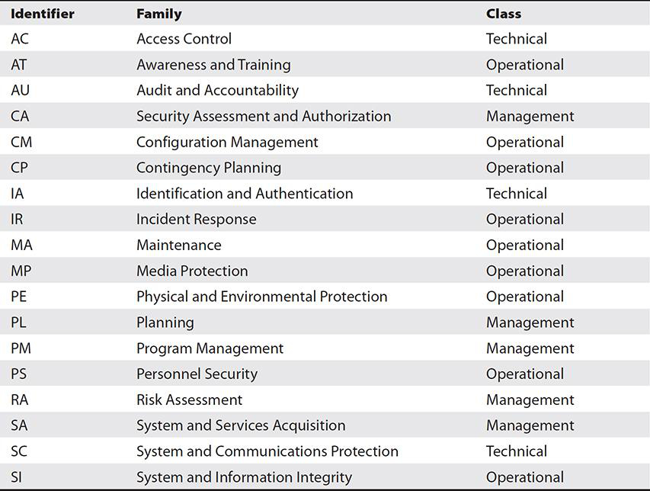
            1. Know what is in which category and generally what each control is

Technical controls can be called logical controls

* + 1. Cyber Security Framework (CSF)
       1. Voluntary Government Framework
       2. 3 main components
          1. Framework Core

activities, outcomes, and references common to all organizations

**Identify** Understand your organization's business context, resources, and risks.

**Protect** Develop appropriate controls to mitigate risk in ways that make sense.

**Detect** Discover in a timely manner anything that threatens your security.

**Respond** Quickly contain the effects of anything that threatens your security.

**Recover** Return to a secure state that enables business activities after an incident.

* + - * 1. Implementation Tiers

How sophisticated your organization is

Partial (tier 1), Risk Informed (tier 2), Repeatable (tier 3), or Adaptive (tier 4)

* + - * 1. Framework Profile

Compare current statuses of categories to possible improvements to align cybersecurity with business priorities

* 1. ISO
     1. Standards/best practices for security controls that companies can get accreditation on
     2. ISO and IEC are known as the ISMS Family of standards = Information Security Management System
  2. Control Objectives for Information and related Technology (COBIT)
     1. Set of objectives to define IT needs (not just security) and align to business needs
        1. Useful as checklist when purchasing products
     2. Provides goals and guidance to companies that they can follow when they purchase, install, test, certify, and accredit IT products
     3. 4 domains
        1. Plan and Organize
        2. Acquire and Implement
        3. Deliver and Support
        4. Monitor and Evaluate
     4. 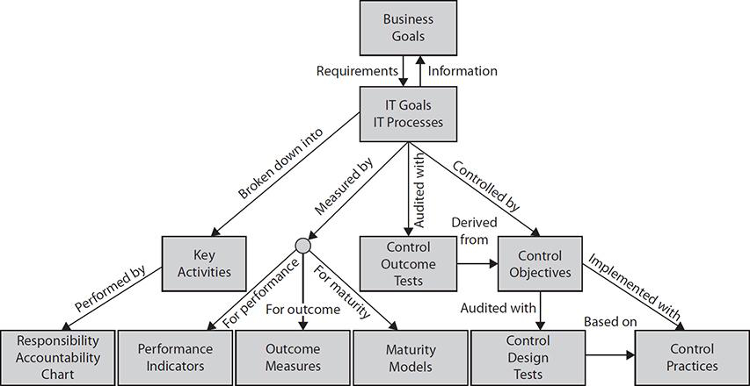
     5. Not high level like ISO
        1. Defines things like password policies and maintaining records of who can access systems
     6. Organizations should meet atleast three goals
  3. SABSA (Sherwood Applied Business Security Architecture)
     1. Uses layers for cybersecurity that increase in specificity as you go
        1. Answers who, what, when, where, why at each level
     2. It is a framework and a methodology
        1. So provides structure and processes for building/maintaining
     3. Gives “Lifecycle model” for architecture
     4. 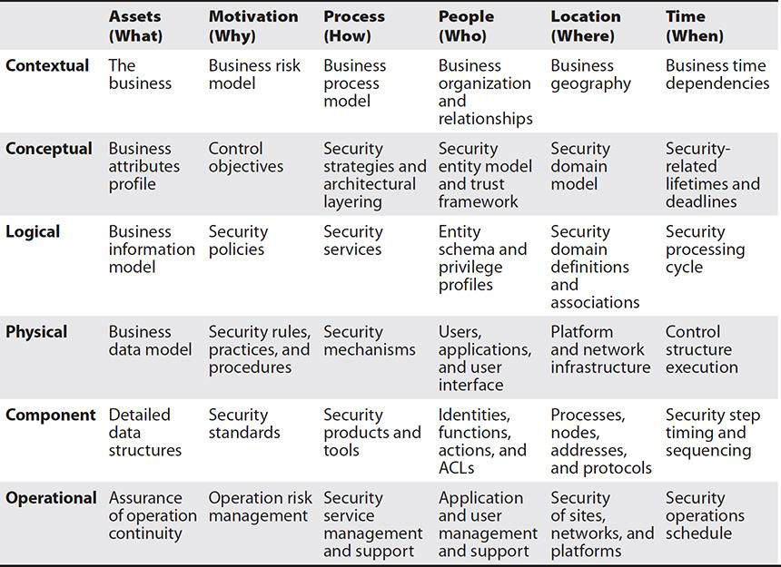
  4. TOGAF
     1. Defines 4 different architecture types
        1. Each one is a way to look at the infrastructure requirements
           1. Business architecture
           2. Data architecture
           3. Applications architecture
           4. Technology architecture
     2. ADM = Architecture development method
  5. ITIL (Information Technology Infrastructure Library)
     1. De facto standard for “Service Management”
     2. Focuses on SLA’s(Service Level Agreements) and bridging gap between IT and businessmen
        1. Security not main focus

1. Policies
   1. Security Policies
      1. Establish a process and consequences for non-compliance
      2. Can be organizational, issue specific or system specific
   2. AUP = Acceptable use policy
      1. Can you use systems for personal stuff
      2. Bans porn and using system for hacking(Things that are unacceptable)
   3. Account management policy
      1. Attackers want to become a “normal” privileged user as soon as possible.
      2. Includes educating new users on what accesses they have
      3. Need change-control processes for adjusting(elevating) privileges
         1. Just have the user without the elevated privileges run as administrator
      4. Suspend accounts that aren’t needed
2. Controls
   1. Organizationally defined parameters
      1. Based on risk appetite
         1. Ex) Backup frequency
   2. Control selection criteria
      1. Baseline controls + law, policy, and regulations
         1. Baseline controls are minimum protections for a specific resource based on risks and risk appetite
      2. Validate controls based on
         1. base risk exposure of the asset,
         2. predicted risk exposure after applying the control,
         3. actual exposure after applying the control
3. Procedures
   1. When continuous monitoring - you need a remediation plan established
   2. Evidence production
      1. The process of producing all information pertinent to a legal proceeding - A legal request for documents, files, or any other tangible item.
      2. AKA e-discovery
         1. E-discovery is technically a subset of evidence production since it doesn’t include seizure
         2. ESI = Electronically Stored Information
      3. Electronic Discovery Reference Model (EDRM) (not all steps required)
         1. **Identification** of data required under the order
         2. **Preservation** of this data to ensure it is not accidentally or routinely destroyed while the order is being complied with
         3. **Collection** of data from the various stores in which it may be housed
         4. **Processing** to ensure the correct format is used for both the data and its metadata
         5. **Review** of the data to ensure it is relevant
         6. **Analysis** of the data for proper context
         7. **Production** of the final data set to those requesting it
         8. **Presentation** of the data to external audiences to prove or disprove a claim
   3. Control testing procedures
      1. Was the control implemented right and does it stop the threat?
   4. Manage exceptions
      1. Defines how to make decisions on when an exception is acceptable
         1. Brings in stakeholders and explains the situation
   5. Remediation plans
      1. Steps to take when security posture gets worse
      2. Points to other procedures to use or improve
         1. Ex) Patching procedure when new vulnerability found
   6. Compensation Control Development
      1. Suppose the machine is old and can’t be patched - Put it on its own VLAN and create ACL so it only talks to a host that has been hardened against attacks
4. Controls
   1. Physical = safeguards that prevent, detect, respond to threats against physical property.
   2. Logical = (Technical controls) software tools to restrict access to an object.
   3. Administrative = “Soft Controls” Management related. Actions to take when Hiring and firing people
5. Common Laws and Regulations
   1. Sarbanes-Oxley Act (SOX)= Protect against trading companies; ensure data records aren’t improperly altered (integrity)
   2. Payment Card Industry Data Security Standard (PCI DSS)= How org handles credit card data
   3. The Gramm-Leach-Bliley Act (GLBA)= Safegaurd Rule; requires financial institutions to protect confidentiality and integrity of personal customer information.
   4. Federal Information Security Management Act (FISMA)= For federal agency and contractors working with info systems. Workers need minimum training, IR, continuity of operations.
   5. Health Insurance Portability and Accountability Act(HIPAA)= Security and Privacy Rules to protect the triad + privacy of patient data.
6. Verifications and quality control
   1. Verification
      1. Ensuring policies are being followed
   2. Quality control
      1. check that controls meet the baselines
   3. Audits
      1. Performed by 3rd party
   4. Evaluations
   5. Assessments
      1. Audits, vulnerability scans, pentests, threat modeling etc.
   6. Maturity model
      1. To what extent does the organization’s security self-improve and monitor potential upcoing issues
      2. If company only handles cyber incidents as they come up then it is immature
         1. CMMI Capability Maturity Model Integration model (not mentioned specifically in exam objectives) maturity levels
            1. Initial= Company doesn’t handle things effectively
            2. Repeatable= Formal structure is in place
            3. Defined= Formal procedures involved; Quantitative process improvements
            4. Managed= Processes for collecting and analyzing quantitative data
            5. Defined Optimizing= Budgeted and integrated plans for continuous process improvement
   7. Certification
      1. Different from accreditation which just means management signed off; management understands security risks associated with the system
   8. Questions
   9. #2
      1. Apparently I need to know the number for the NIST publication 800-53
         1. 800-37 might not hurt either
   10. CSF seems to be the focus
   11. Got #10 wrong -Matt

**Chapter 12 Identity and Access Management**

1. Context based authentication
   1. Requires collecting info on users’ usual habits
      1. The context can be spoofed
   2. Biometrics are context-based??
      1. Maybe if you’re signing in using your phone, the context is you already used your fingerprint to get on your phone
   3. **Behavior**
   4. Time
      1. Spoof a different time zone to login later/earlier
      2. **Time** and **location** need to be monitored together
      3. Time context also refers to RSA tokens since the number is based on time and private key
   5. A-GPS = Assisted GPS
      1. Uses cell tower triangulation to help locate you
   6. Frequency
      1. Too many requests too quick can’t be from a human
   7. Behavior
      1. How you operate once already logged in is recorded to determine if your session is hijacked
         1. AI is making computer behavior able to mimic humans better
   8. Digital Identity refers to a distinct representation of a real-world subject within an information system.
   9. IDM = Identity management system
   10. Defense Advanced Research Projects Agency calls this process "Active Authentication" “cognitive fingerprint” based on the user behavior with the machine
2. Kerberos
   1. Have to understand architecture and use of keys and tickets for CySA
      1. There is a walkthrough of this in this chapter but it’s so confusing!
      2. Uses symmetric encryption for session security
      3. Three components:
         1. AS , TGS. KDC
   2. AS = Authentication Service
   3. TGS = Ticket Granting Server
   4. KDC = key distribution center
   5. TGT = Ticket Granting Ticket
3. Identity Services
   1. Service Identity and Authentication
      1. For The service to authenticate to the client
      2. Windows .NET framework feature
         1. Used by Windows Communication Foundation (WCF)
            1. An infrastructure for cross-service communication
      3. After service authenticates to a client by normal means, client compares a stored endpoint identity to a value the service provides.
         1. Book doesn’t say where it gets this from
         2. Endpoint Identities are made of pieces of certificates, DNS info, RSA value, etc.
         3. It’s basically a 2nd authentication
      4. X.509 used to authenticate the servers
      5. Certificate Authority (CA)
4. Identity Repositories
   1. Directory Service= a central repo for storing and managing information
   2. Active Directory
      1. Object Access Auditing
         1. Option in AD to detect changes to AD
         2. Works well with a SIEM and event logging
      2. Control over the AD domain controllers means control over the entire network
   3. LDAP
      1. Lightweight directory access protocol - cross-platform open standard for maintaining directory services on a network
      2. 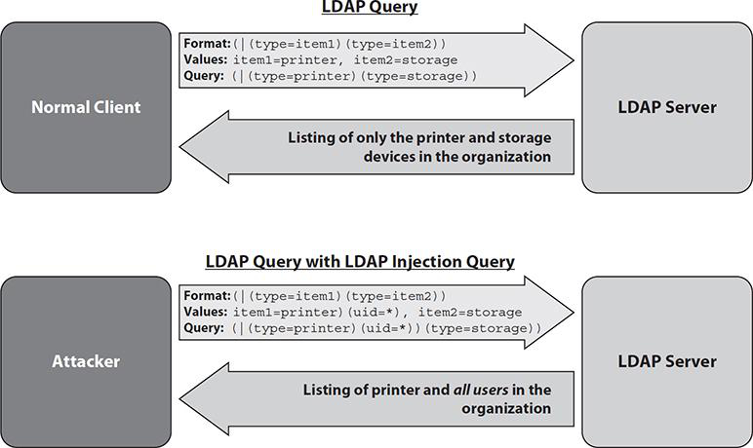
         1. Example of inserting LDAP code maliciously on a server where the user should only have access to storage devices and printers
            1. Input validation to escape special characters (like the wildcard above) and regex fixes this
   4. TACACS+ =Terminal Access Controller Access Control System Plus
      1. User attempting access to server is compared to a database of access levels
      2. AAA = authentication, authorization, and accounting
         1. Works for device and network AAA
      3. Vulnerable to replay attacks
         1. Uses TCP, but begins every session with SEQ number 1
         2. Small number of possible session IDs makes it vulnerable to birthday attacks
   5. RADIUS = Remote Authentication Dial-In User Service
      1. Like TACACS+ but doesn’t encrypt usernames (only passwords)
      2. Uses UDP not TCP
         1. Easier to spoof packets
      3. Can use a shared secret to authenticate
         1. Entire network can be compromised by one exploited endpoint
      4. Sometimes vulnerable to buffer overflow
   6. Federated identity
      1. Federated Identity Manager
         1. A third party can verify your identity for multiple services (like google, facebook etc.)
   7. SSO = Single Sign On
      1. Often used for multiple services in one organization
         1. Often uses LDAP databases
            1. Often Uses SAML (Security Assertion Markup Language)
      2. IDP = Identity Provider
      3. SP = Service Provider
      4. Larger impact if credentials are compromised
         1. Multi-factor and context based authentication helpful
      5. SSO system is a critical system since loss means loss of access to everything
   8. Provisioning
      1. Refers to all the things that have to happen to create an account and set accesses, roles, etc
      2. Auto-provisioning means when an IDP certifies a user should have an account on a new service, it is automatically created
         1. Have to control attack surface with limited options for auto-provisioning
5. MITM = Man in the Middle
   1. Impersonation is both ways. The attacker is playing both the client and the server.
6. Session Hijack
   1. HTTP sessions are stateless and can use multiple TCP connections
      1. So HTTP sessions are tracked through cookies, the URL, or other pieces of HTTP protocol
         1. Attacker can predict session token info, MITM, or capture existing session info and use it
7. XSS = Cross Site Scripting
   1. Persistent XSS
      1. Malicious code stored on the site
         1. often as a post on a message board etc.
   2. Non-persistent XSS AKA Reflected XSS
      1. Can create a link to a vulnerable website that user clicks which causes browser to execute code

**Chapter 13 Compensating Controls**

1. Trend Analysis Vs Historical Analysis
   1. Trend predicts future :: Historical compares new observations to the past
2. SDN = Software Defined Networking
   1. Makes correlation way easier cause tons of data capture can be done centrally
3. Syslog
   1. Messaging protocol standardizing system event reporting
      1. Syntax of actual logs can vary some, this is just for getting it to the right place
   2. Linux syslog process called syslogd
      1. Linux based routers, switches, and firewalls do this too
   3. No pre-installed syslog in windows
   4. Has facility code and severity code
      1. Facility code = source of message
      2. Severity code = 0 is worst 5-7 are normal
         1. 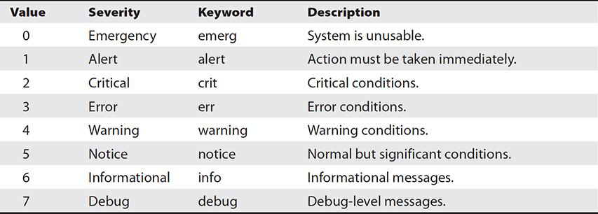
4. Authentication logs
   1. EXAM TIP ; Pay attention to time zones on these!
   2. Linux has auth.log file
5. Windows Event Viewer
   1. Successful logins have event id 4624; failures 4625
6. LInux application logs are at /var/log directory
   1. Other systems syslogs may vary
7. Dual Control
   1. requiring two people to perform similar tasks in order to gain access to a controlled asset
   2. Ex) Login with password but having to call op center for hardware token code
8. Separation of duties
   1. places the subordinate tasks for a critical function under dispersed control
9. Security Appliances
   1. One device that can act as IDS/IPS, firewall, content filter, packet capture and load balancer
   2. Often has a dashboard to view all functions
      1. Can also email this info regularly
10. MDM = Mobile Device Management
11. Security Suites AKA multilayered security
    1. Software suites including MDM, endpoint scanning and protection, and phishing detection
12. Questions
    1. #1
       1. Historical analysis more useful than packet analysis since you can figure out whether this person normally uploads data
          1. Packet analysis would be hard to sort through everything for sensitive files
    2. #2
       1. Apparently can’t assume there are syslog files on other machines they might be referring to
    3. #3 wrong - Matt
    4. #9 wrong - Matt
       1. They didn’t mention any need for SSH on the server, so I guess it’s safe to assume there isn’t one
          1. Better passwords would keep the attack from working so incredibly fast, but this asked what would stop it entirely

**Chapter 14 Secure Software Development**

1. Non-functional requirements AKA Quality requirements
   1. How the software has to work due to constraints like taking certain inputs/outputs that are compatible elsewhere
2. Function requirements
   1. What the software must do
3. O&M = Operation and Maintenance
4. TCO = Total Cost of Ownership
5. DBMS = Database Management System
6. Parameter validation
   1. Works within code on inputs to parameters that are normally out of user’s manipulation, but that user could take advantage of anyways
      1. Ex) [string]$variable = …
7. Regression testing
   1. Making sure a fix to code doesn’t break it or bring new vulnerabilities elsewhere
8. Interception Proxy
   1. Used to check all data sent between web or mobile app being developed and simulated client
   2. Can test:
      1. Input validation
      2. Parameter Validation
         1. Validate fields can’t be modified by user or are validated on server
      3. Plaintext credentials
         1. Harder to ensure mobile devices use HTTPS for passwords
      4. Session Tokens
         1. Check that session IDs are generated truly randomly
9. Fuzzing - used to discover flaws and vulnerabilities
10. Stress testing - attempts to break the software
11. OWASP = Open Web Application Security Project
    1. Organization for web based security issues
    2. Has a top ten list
       1. Exam objectives just say OWASP. I doubt I need to memorize this list, but the book doesn’t say much more about OWASP
          1. A1: Injection
          2. A2: Broken Authentication and Session Management
          3. A3: Cross-Site Scripting (XSS)
          4. A4: Insecure Direct Object References
          5. A5: Security Misconfiguration
          6. A6: Sensitive Data Exposure
          7. A7: Missing Function Level Access Controls
          8. A8: Cross-Site Request Forgery (CSRF)
          9. A9: Using Components with Known Vulnerabilities
          10. A10: Unvalidated Redirects and Forwards
12. SANS
    1. “Secure the Human” classes include developer classes
    2. Best practices
       1. Doubtful that I need to memorize these. Probably just be familiar with them and know what SANS does generally
          1. *Display generic error messages*
          2. *Implement account lockouts*
          3. *Limit sensitive data use*
          4. *Use HTTPS everywhere*
          5. *Use parameterized SQL queries*
          6. *Automate application deployment*
             1. Meaning script its configuration so you can’t mess up an instance of it
13. CIS = Center for Internet Security
    1. Nonprofit that collaborates with private and gov sectors for threat intel
    2. Creates System Design recommendations based on consensus from members and partners
    3. Detailed “Benchmarks” for how to secure specific platforms =
       1. Also some pre-configured system images available
    4. Multi-State Information Sharing and Analysis Center (MS-ISAC) focuses on state, local, tribal, and territorial (SLTT) government partners and vulnerability mitigation and incident response
14. Questions
    1. #10
       1. Very sneaky: They added the word “actively” and I didn’t notice
       2. I guess the internal accounting server counts as a web app so it’s not D

**Chapter 15 Tools**

##### **EXAM TIP:** You do not need to know these tools in detail for the exam, but you do need to know when and how you would use the different classes of tools.

* 1. Exam objectives say Compare and contrast the general purpose and reasons for using various cybersecurity tools and technologies. (**The intent of this objective is NOT to test specific vendor feature sets.)
  2. So in other words know about them, but no performance based questions where you have to use them

1. Preventative Tools
   1. NGFW = Next Generation Firewall
      1. Specifically means a firewall that’s also an IPS and can utilize A/D, whitelists, blacklists, and policy servers
      2. It is cloud based
      3. I should generally know how to read a firewall rule (not hard)
      4. 3 companies to know about:
         1. 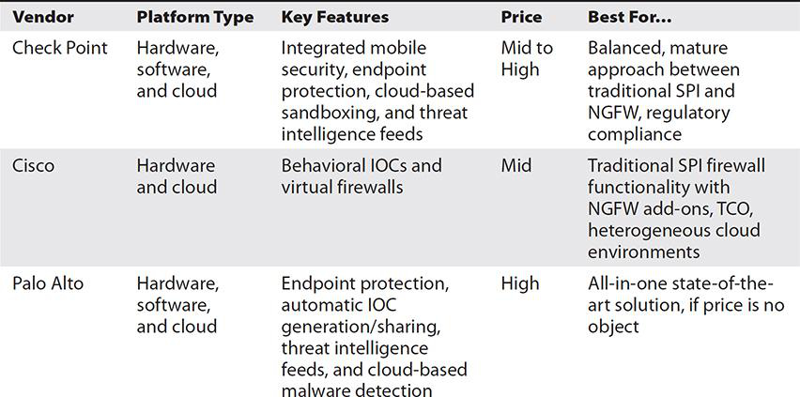
         2. Check Point
            1. Not at the leading edge, but does a good job when implements things
            2. Good reputation for large complex architectures

Also fits some niche needs like SCADA

* + - 1. Cisco
         1. Not as robust or innovative as the other two
         2. Best with traditional firewall features
         3. Lower TCO (= total cost of ownership)
         4. Subscription based service for cloud working with hardware
         5. Mainly used on systems already based on Cisco products
      2. Palo Alto
         1. First in new features
         2. Detects new threats faster because well integrated
         3. Expensive as hell
  1. Network based IDS and IPS
     1. 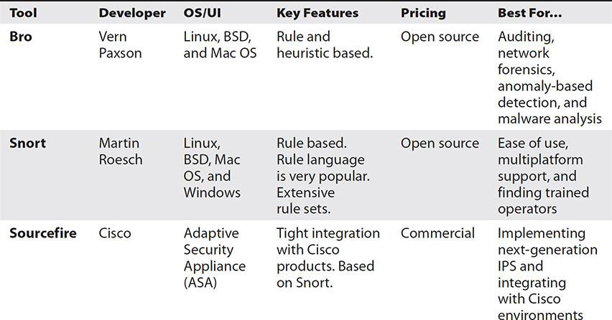
     2. Bro
        1. Open Source
        2. Not actually made to be an IPS (technically and IDS)
           1. But powerful scripting rules make it possible
        3. Records everything
     3. Snort
        1. Open Source
        2. Also an IDS that is used as IPS
        3. Anomaly & Signature based
        4. Scripting not as powerful as bro
        5. Doesn’t record everything by default
     4. Sourcefire
        1. Cisco Adaptive Security Appliance product with annual license
           1. Cost based on number of units
        2. Commercial support available
  2. Host-Based IPS
     1. HIPS = Host based Intrusion Prevention System = only inpects and responds to traffic in and out of the host’s network interfaces
     2. EMET = Enhanced Mitigation Experience Toolkit
        1. Free windows product against Zero-Days
        2. Data Execution Prevention
        3. Address Space Layout Randomization
        4. Control Flow Guard
           1. Prevents attacks that take over the “flow” of processes by mapping the normal flow
     3. Web Proxy
        1. intercepts and then forwards web traffic between clients and servers.
        2. Make sure org policy states traffic will be monitored
        3. Ensure all clients trust the web proxy as a certificate authority
  3. WAF = Web Application Firewall
     1. Protect Servers by reading traffic
        1. Requires understanding specific web apps
     2. 3 types to know
        1. Imperva SecureSphere
           1. Dynamic Profiling

Learns baseline behavior of apps/users

* + - * 1. Exchanges threat signatures with cloud
        2. Soooooo expensive
      1. ModSecurity
         1. Open Source

Apache

* + - * 1. Accesses OWASP’s Core Rule Set for rule based detection
        2. Can aggregate smaller matches into higher alert (anomaly-based)

Can catch small incremental attacks

* + - 1. NAXSI = Nginx *Anti XSS and SQL Injection*
         1. Nginx is an open source web server
         2. For high performance environments

Only focuses on small rule set with strict policies

Deny by default

Can automatically generate whitelists

* + - 1. 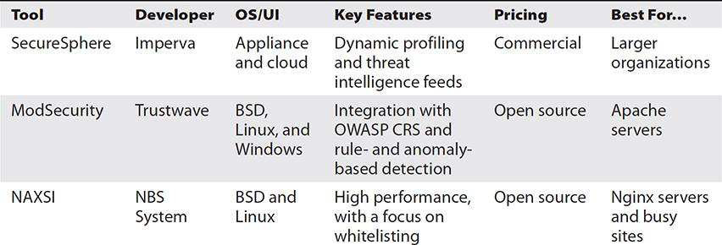

1. Collective Tools
   1. SIEM
      1. 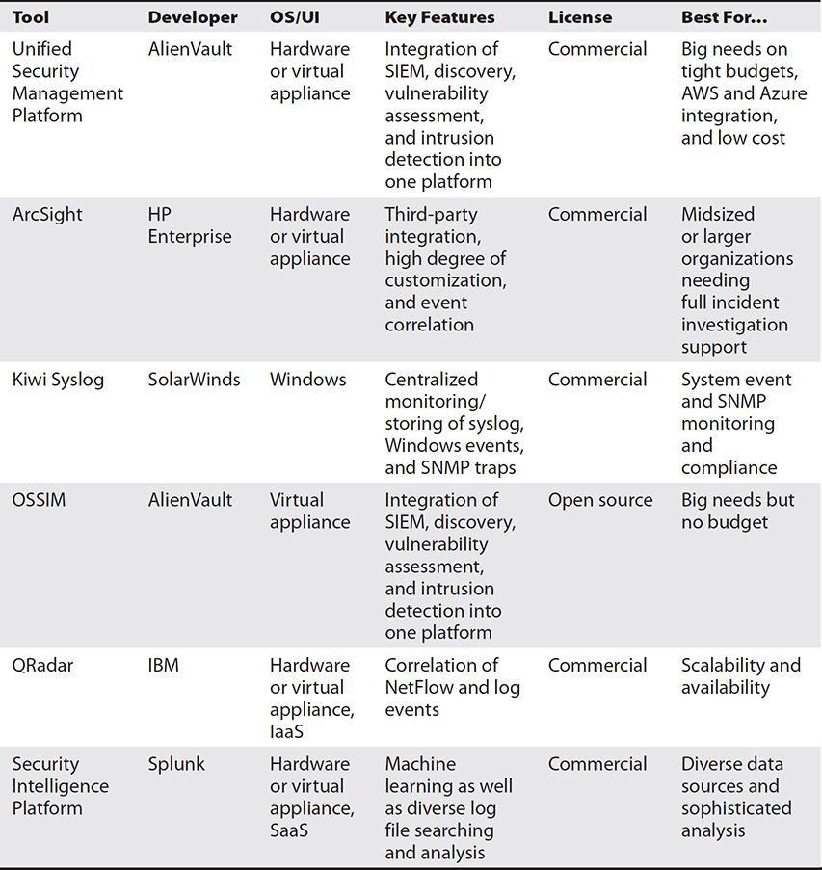
      2. USM = Unified Security Management Platform
         1. Subscription and crowdsourced threat intel services
      3. ArcSight
         1. Modules for optional protections
         2. Can integrate with most security solutions
         3. User behavior Analytics
      4. Kiwi Syslog
         1. Not technically a SIEM
            1. More of a syslog monitoring tool for compliance purposes
         2. Can integrate logs from windows and linux
      5. OSSIM = Open Source Security Information Manager
         1. Unified interface of many open source tools
            1. Includes OpenVAS
      6. QRadar
         1. Integrates NetFlows, packet captures, and event results
            1. Tracks “offenses” rather than events

Basically one offense contains all the related log files, network info, affected hosts and relevant vulnerabilities

* + - 1. Will automatically start forensic data acquisition
    1. SIP = Security Intelligence Platform (Splunk)
       1. User behavior analytics
       2. Analysis and indexing are strengths
  1. Network Scanning
     1. NMAP
        1. Horizontal scan = send message to a set of host addresses asking “Are you there”
        2. Vertical scan = need messages to protocol/port combos
        3. Just remember this is a network scanner not a vulnerability scanner
  2. CLI = Command Line Interface
  3. BSD = Berkeley Software Distribution
     1. An OS based on UNIX
  4. Packet Capture
     1. Switch port analyzer (SPAN)
     2. 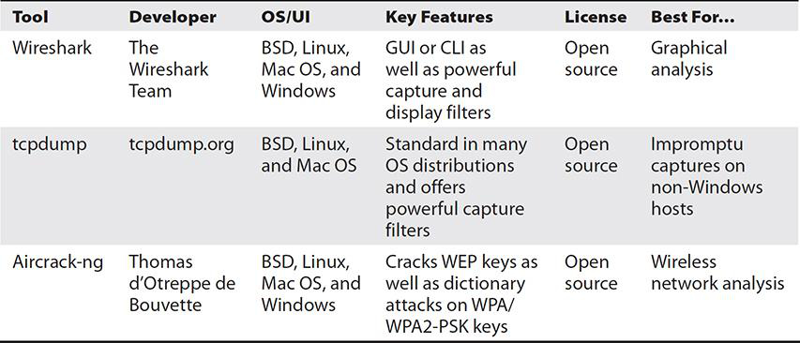
     3. Tcpdump is a command in the CLI for most OS’s
     4. Aircrack-ng
        1. More of a pen-test tool for wifi, but can do full packet capture
           1. Really just for wifi either way
  5. Learn the uses for these Command Line Utilities
     1. Netstat, Command line/IP utilities
     2. netstat
     3. ping
     4. tracert/traceroute
     5. ipconfig/ifconfig
     6. nslookup/dig
     7. OpenSSLtill
        1. Software library containing SSL and TLS
        2. Has CLI to..
           1. Generate and validate certificates.
           2. Generate, sign, and verify MD5 and SHA hashes.
           3. Encrypt and decrypt data.
           4. Establish secure connections to remote servers
     8. Sysinternals
        1. **Process Explorer**
           1. Gives process info, CPU/RAM usage, what started it, and VirusTotal score
        2. **Autoruns**
           1. view /manage OS and user startup pgms
        3. **Process Monitor**
           1. Process resources like registry keys, DLLs, files, and other processes
  6. Analytical Tools
     1. Vulnerability Scanning
        1. 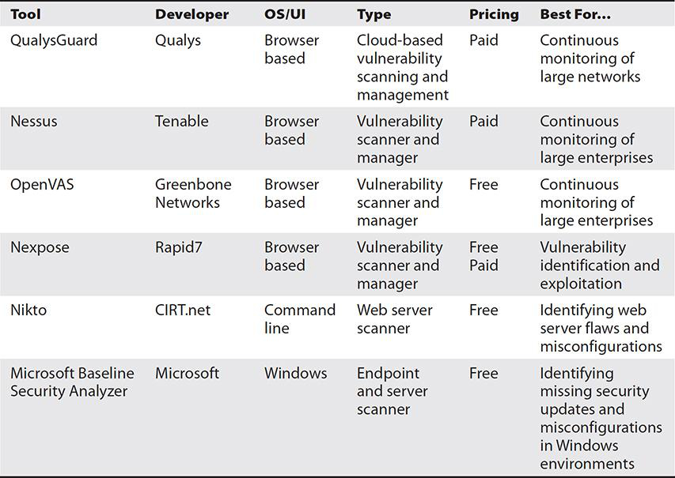
        2. QualysGuard
           1. Web based interface that can generate reports with templates
           2. Tracks discovery, mapping, asset prioritization, scheduling, vulnerability assessment reporting, and remediation
        3. Nessus
           1. 80,000 plugins
           2. Web based interface with severity levels
           3. Good at compliance checking
           4. Can make report of just one exploit’s vulnerabilities and possible remediations
        4. OpenVAS
           1. Relies on community to maintain library
           2. No on demand customer support
           3. Looks all grey and blocky like a windows 98 system
        5. Nexpose
           1. More focused on vulnerability management life cycle

Organized by asset by default and takes asset value into account for risk rating

* + - * 1. Integrated with Metasploit
      1. Nikto
         1. Command line based
         2. Quickly scans web server vulnerabilities
      2. Microsoft Baseline Security Analyzer
         1. Really just checks for missing patches and misconfigurations on windows machines
         2. Works over network not just end-point
    1. Monitoring Tools
       1. 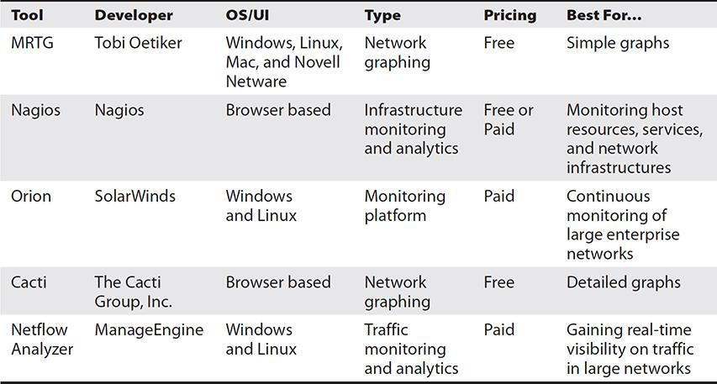
       2. MRTG = Multi Router Traffic Grapher
          1. Relies on SNMP
          2. Fast and lightweight

Can store years worth of logs without much issue

Really just outputs small graphs and nothing else

* + - 1. Nagios
         1. Nagios Core is open source
         2. Nagios XI is paid

Difference is reports can be more complex dashboards, graphs, reports

* + - 1. Orion
         1. Other Solar Winds products like protocol analyzer rely on Orion as a framework
      2. Cacti
         1. Graph maker based on MRTG
         2. Also very low system reqs

Seems to do a bit more than MRTG

* + - * 1. Browser based
      1. NetFlow Analyzer
         1. Easy to analyze traffic and bandwidth usage
         2. Add-on for forensic and security features
    1. Interception Proxy
       1. 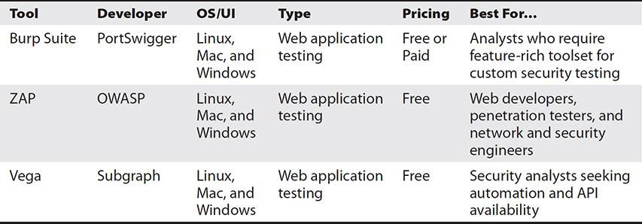
       2. Burp Suite
          1. Choose whether to forward intercepted requests
          2. Find and exploit vulnerabilities
          3. Paid version offers more automation for scanning
       3. ZAP
          1. Can modify packet contents before forwarding (MITM attack)
          2. Can do DoS attack targeted at directories (including non-public ones) to determine if misconfigured
       4. Vega
          1. Scanning, XSS vulnerability, injection discovery
          2. Tells you how to remediate discovered vulnerabilities
  1. Exploitative Tools
     1. Exploitation Frameworks
        1. 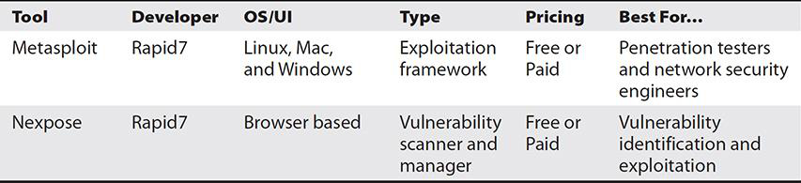
        2. Metasploit
           1. Uses modules for different exploits
           2. Can add payloads to exploits

Will execute code once it succeeds

* + - 1. Nexpose
         1. A vulnerability scanner that integrates with metasploit for exploitation

Doesn’t really belong in this category

* + 1. Fuzzers
       1. 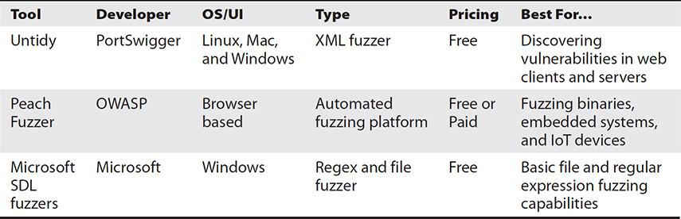
       2. Untidy
          1. Modifies legitimate XML
          2. Now part of the Peach Fuzzer project
       3. Peach Fuzzer
          1. Suite of XML based modules

It calls modules “pits” for the lawls

* + - 1. Microsoft SDL Fuzzers
         1. MiniFuzz and Regex Fuzzer

Were part of security development lifecycle products

Both are no longer supported

* 1. Forensic Tools
     1. Forensic Suites
        1. 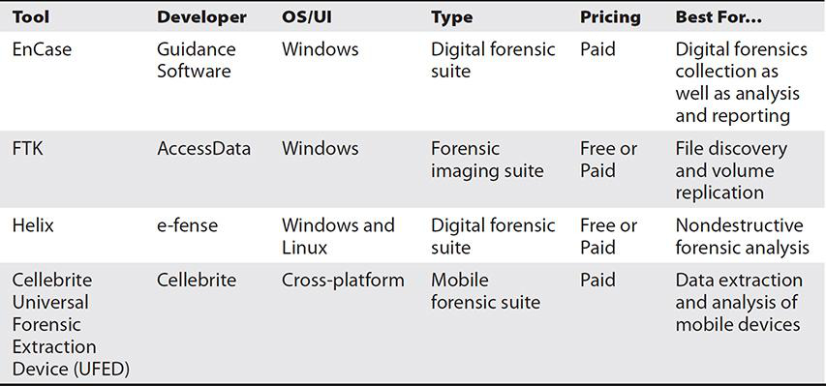
        2. EnCase
           1. Nothing that wasn’t in Ch 9 already
        3. FTK
           1. Also covered in Ch 9
           2. Built in logging of the analysis itself
        4. Helix
           1. Can image all internal devices
           2. Can do mobile device analysis
        5. Cellebrite
           1. Handheld device for extracting mobile device data
           2. Marketed to military and law enforcement
     2. Hashing
        1. 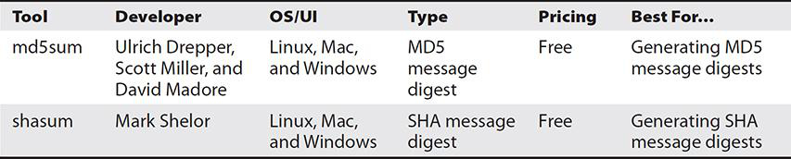
        2. md5sum
           1. Command line utility included with linux
           2. Weaknesses have been discovered
           3. 128 bit MD5 hash
        3. Shasum
           1. Command line utility

Can use -a parameter for different hash algorithms

* + 1. Password Cracking
       1. 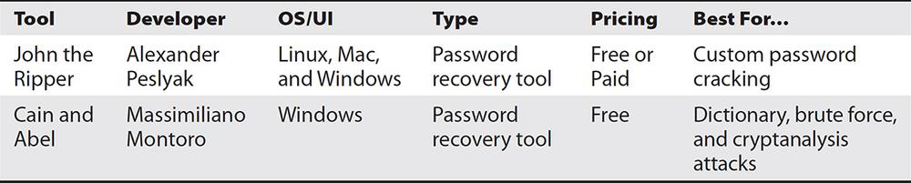
       2. John the Ripper
          1. Detects password hash types

More hash types in paid versions

* + - 1. Cain and Abel
         1. Not supported beyond windows vista

Need workarounds

* + - * 1. Can use Rainbow tables

Rainbow tables are pre-computed lists of hashes

* + 1. Imaging
       1. dd
          1. Already covered Ch 9
  1. Questions
     1. #8
        1. NMAP can check for specific ports apparently
     2. #10
        1. CySA prefers SHA over MD5 hash